Q1.
Figure 1 shows a measuring cylinder containing some water.
Figure 1
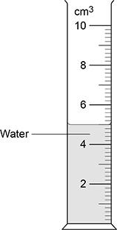
(a) What range of volumes can be measured using the measuring cylinder?
Tick (✓) one box.

0.0 to 0.2 cm³ | 
0.0 to 2.0 cm³
0.0 to 10.0 cm³
(1)
A student used the measuring cylinder to measure the volume of a metal ring.
(b) The student tied the metal ring to some very thin string and lowered the ring into the measuring cylinder.
The student could have used thick string instead of thin string.
How would using thick string have affected the measured volume of the metal ring?
Tick (✓) one box.

The measured volume would be smaller.
The measured volume would not be affected.
The measured volume would be larger.
(1)
(c) The table below shows the results.

Volume of water in cm³ | Volume of water and ring in cm³ | Volume of ring in cm³
5.0 | 5.4 | X
Calculate value X in above table.
___________________________________________________________________
___________________________________________________________________
X = ____________________ cm³
(1)
(d) The student measured the volume of the ring three times.
The results were all the same.
Which of the following describes the student s results?
Tick (✓) one box.

The results are anomalies.
The results are repeatable.
The results contain random errors.
(1)
(e) The student used a balance to measure the mass of the ring.
Figure 2 shows the balance.
Figure 2
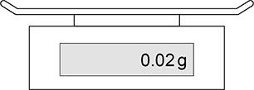
The student noticed that the balance had a reading of 0.02 g when there was no object on the balance.
How should the student correct this error after the mass of the ring had been measured?
Tick (✓) one box.

Add 0.02 to the measurement
Divide the measurement by 0.02
Multiply the measurement by 0.02
Subtract 0.02 from the measurement
(1)
Use the Physics Equations Sheet to answer parts (f) and (g).
(f) Write down the equation which links density (ρ), mass (m) and volume (V).
___________________________________________________________________
(1)
(g) A different metal ring has a volume of 0.3 cm³.
The density of this ring is 22 g/cm³.
Calculate the mass of this ring.
Give your answer in grams.
___________________________________________________________________
___________________________________________________________________
___________________________________________________________________
___________________________________________________________________
___________________________________________________________________
Mass = ____________________ g
(3)
(Total 9 marks)
Q2.
(a) The diagrams, X, Y and Z, show how the particles are arranged in the three states of matter.
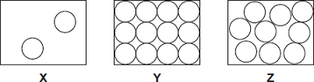
(i) Which one of the diagrams, X, Y or Z, shows the arrangement of particles in a liquid?
Write the correct answer in the box. 
(1)
(ii) Which one of the diagrams, X, Y or Z, shows the arrangement of particles in a gas?
Write the correct answer in the box.
(1)
(b) Draw a ring around the correct answer in each box to complete each sentence.

 |  | vibrating in fixed positions.
(i) | In a gas, the particles are | moving randomly.
 |  | not moving.
(1)

 |  | stronger than
(ii) | In a solid, the forces between the particles are | equal to | the
 |  | weaker than
forces between the particles in a liquid.
(1)
(c) The picture shows a puddle of water in a road, after a rain shower.
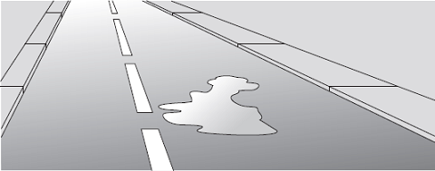
(i) During the day, the puddle of water dries up and disappears. This happens because the water particles move from the puddle into the air.
What process causes water particles to move from the puddle into the air?
Draw a ring around the correct answer.

condensation | evaporation | radiation
(1)
(ii) Describe one change in the weather which would cause the puddle of water to dry up faster.
______________________________________________________________
______________________________________________________________
(1)
(Total 6 marks)
Q3.
A student wanted to determine the density of a small piece of rock.
(a) Describe how the student could measure the volume of the piece of rock.
___________________________________________________________________
___________________________________________________________________
___________________________________________________________________
___________________________________________________________________
___________________________________________________________________
___________________________________________________________________
___________________________________________________________________
___________________________________________________________________
___________________________________________________________________
___________________________________________________________________
(4)
(b) The volume of the piece of rock was 18.0 cm³.
The student measured the mass of the piece of rock as 48.6 g.
Calculate the density of the rock in g/cm³.
Use the equation:
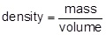
___________________________________________________________________
___________________________________________________________________
___________________________________________________________________
___________________________________________________________________
Density = _______________________ g/cm³
(2)
The graph below shows the densities of different types of rock.
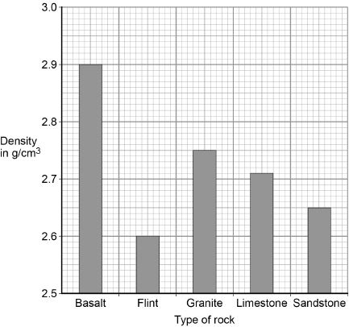
(c) What is the most likely type of rock that the student had?
Tick one box.

Basalt | 
Flint
Granite
Limestone
Sandstone
(1)
(d) Give one source of error that may have occurred when the student measured the volume of the rock.
___________________________________________________________________
___________________________________________________________________
(1)
(e) How would the error you described in part (d) affect the measured volume of the rock?
___________________________________________________________________
___________________________________________________________________
(1)
(Total 9 marks)
Q4.
(a) A student investigated the three states of matter.
The arrangement of particles in the three states of matter are different.
Draw one line from each particle arrangement to the state of matter.
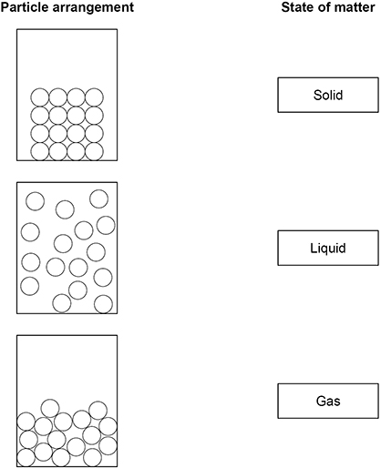
(2)
A large lump of ice was heated and changed state.
The figure below shows how the temperature varied with time.
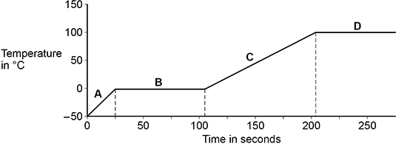
(b) Which part of the figure above shows when the ice was melting?
Tick (✓) one box.

A |  | B |  | C |  | D
(1)
(c) Which part of above the figure above shows when the water was boiling?
Tick (✓) one box.

A |  | B |  | C |  | D
(1)
(d) Which property of the water particles changes as the temperature of the water increases?
Tick (✓) one box.

The kinetic energy of the particles
The mass of each particle
The number of particles
(1)
(e) Calculate the thermal energy needed to melt 0.250 kg of ice at 0 °C.
specific latent heat of fusion of water = 334 000 J/kg
Use the equation:
thermal energy = mass × specific latent heat
___________________________________________________________________
___________________________________________________________________
___________________________________________________________________
Thermal energy = _______________ J
(2)
(f) Complete the sentence.
Choose the answer from the box.

condenses | evaporates | ionises | sublimates
A substance is heated and changes directly from a solid to a gas.
The substance _______________.
(1)
(Total 8 marks)
Q5.
A student investigated the density of different fruits.
To determine the density of each fruit, the student measured the volume of each fruit.
The figure below shows the equipment the student could have used.
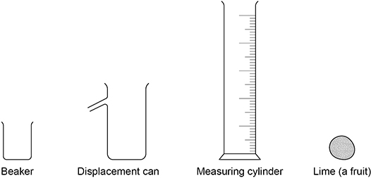
(a) Describe a method the student could have used to measure the volume of the lime.
___________________________________________________________________
___________________________________________________________________
___________________________________________________________________
___________________________________________________________________
___________________________________________________________________
___________________________________________________________________
___________________________________________________________________
___________________________________________________________________
___________________________________________________________________
___________________________________________________________________
___________________________________________________________________
___________________________________________________________________
(4)
(b) The student measured the volume of each fruit three times and then calculated a mean value.
The three measurements for a grape were
2.1 cm³ 2.1 cm³ 2.4 cm³
Calculate the mean value.
___________________________________________________________________
___________________________________________________________________
___________________________________________________________________
Mean value = _______________ cm³
(2)
(c) What are the advantages of taking three measurements and calculating a mean value?
Tick (✓) two boxes.

Allows anomalous results to be identified and ignored.
Improves the resolution of the volume measurement.
Increases the precision of the measured volumes.
Reduces the effect of random errors when using the equipment.
Stops all types of error when using the equipment.
(2)
(d) The mass of an apple was 84.0 g.
The volume of the apple was 120 cm³.
Calculate the density of the apple.
Give your answer in g/cm³.
Use the equation:
___________________________________________________________________
___________________________________________________________________
___________________________________________________________________
Density = _______________ g/cm³
(2)
(Total 10 marks)
Q6.
The figure below shows a balloon filled with helium gas.
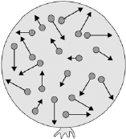
(a) Describe the movement of the particles of helium gas inside the balloon.
___________________________________________________________________
___________________________________________________________________
___________________________________________________________________
___________________________________________________________________
(2)
(b) What name is given to the total kinetic energy and potential energy of all the particles of helium gas in the balloon?

Tick one box.
External energy | 
Internal energy
Movement energy
(1)
(c) Write down the equation which links density, mass and volume.
___________________________________________________________________
(1)
(d) The helium in the balloon has a mass of 0.00254 kg.
The balloon has a volume of 0.0141 m³.
Calculate the density of helium. Choose the correct unit from the box.

m³ / kg kg / m³ kg m³
___________________________________________________________________
___________________________________________________________________
___________________________________________________________________
___________________________________________________________________
Density = __________________ Unit _________
(3)
(Total 7 marks)
Q7.
(a) A company is developing a system which can heat up and melt ice on roads in the winter. This system is called ‘energy storage’.
During the summer, the black surface of the road will heat up in the sunshine.
This energy will be stored in a large amount of soil deep under the road surface.
Pipes will run through the soil. In winter, cold water entering the pipes will be warmed and brought to the surface to melt ice.
The system could work well because the road surface is black.
Suggest why.
___________________________________________________________________
___________________________________________________________________
(1)
(b) (i) What is meant by specific latent heat of fusion?
______________________________________________________________
______________________________________________________________
______________________________________________________________
______________________________________________________________
(2)
(ii) Calculate the amount of energy required to melt 15 kg of ice at 0 °C.
Specific latent heat of fusion of ice = 3.4 × 10⁵ J/kg.
______________________________________________________________
______________________________________________________________
Energy = ___________________ J
(2)
(c) Another way to keep roads clear of ice is to spread salt on them.
When salt is added to ice, the melting point of the ice changes.
A student investigated how the melting point of ice varies with the mass of salt added.
The figure below shows the equipment that she used.
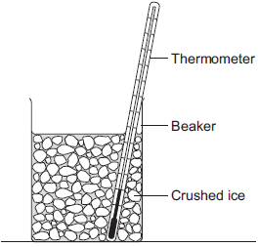
The student added salt to crushed ice and measured the temperature at which the ice melted.
(i) State one variable that the student should have controlled.
______________________________________________________________
______________________________________________________________
(1)
(ii) During the investigation the student stirred the crushed ice.
Suggest two reasons why.
Tick () two boxes.

Tick ()
To raise the melting point of the ice
To lower the melting point of the ice
To distribute the salt throughout the ice
To keep all the ice at the same temperature
To reduce energy transfer from the surroundings to the ice
(2)
(iii) The table below shows the data that the student obtained.

Mass of salt added in grams | 0 | 10 | 20
Melting point of ice in °C | 0 | -6 | -16
Describe the pattern shown in the table.
______________________________________________________________
______________________________________________________________
(1)
(d) Undersoil electrical heating systems are used in greenhouses. This system could also be used under a road.
A cable just below the ground carries an electric current. One greenhouse system has a power output of 0.50 kW.
Calculate the energy transferred in 2 minutes.
___________________________________________________________________
___________________________________________________________________
___________________________________________________________________
Energy transferred = ___________________ J
(3)
(e) In this question you will be assessed on using good English, organising information clearly and using specialist terms where appropriate.
A local council wants to keep a particular section of a road clear of ice in the winter.
Describe the advantages and disadvantages of keeping the road clear of ice using:
• energy storage
• salt
• undersoil electrical heating.
___________________________________________________________________
___________________________________________________________________
___________________________________________________________________
___________________________________________________________________
___________________________________________________________________
___________________________________________________________________
___________________________________________________________________
___________________________________________________________________
___________________________________________________________________
___________________________________________________________________
___________________________________________________________________
___________________________________________________________________
Extra space _________________________________________________________
___________________________________________________________________
___________________________________________________________________
___________________________________________________________________
___________________________________________________________________
___________________________________________________________________
___________________________________________________________________
(6)
(Total 18 marks)
Q8.
Solid, liquid and gas are three different states of matter.
(a) Describe the difference between the solid and gas states, in terms of the arrangement and movement of their particles.
___________________________________________________________________
___________________________________________________________________
___________________________________________________________________
___________________________________________________________________
___________________________________________________________________
___________________________________________________________________
___________________________________________________________________
___________________________________________________________________
___________________________________________________________________
___________________________________________________________________
___________________________________________________________________
(4)
(b) What is meant by ‘specific latent heat of vaporisation’?
___________________________________________________________________
___________________________________________________________________
___________________________________________________________________
___________________________________________________________________
(2)
(c) While a kettle boils, 0.018 kg of water changes to steam.
Calculate the amount of energy required for this change.
Specific latent heat of vaporisation of water = 2.3 × 10⁶ J / kg.
___________________________________________________________________
___________________________________________________________________
___________________________________________________________________
Energy required = __________________ J
(2)
(d) The graph shows how temperature varies with time for a substance as it is heated.
The graph is not drawn to scale.
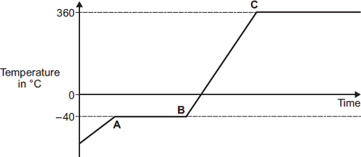
Explain what is happening to the substance in sections AB and BC of the graph.
Section AB _________________________________________________________
___________________________________________________________________
___________________________________________________________________
___________________________________________________________________
___________________________________________________________________
Section BC _________________________________________________________
___________________________________________________________________
___________________________________________________________________
___________________________________________________________________
___________________________________________________________________
(4)
(Total 12 marks)
Q9.
The figure below shows a measuring cylinder containing some water, which a student used to measure the volume of a metal ring.
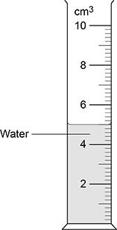
(a) When measuring the volume, the student s eye was in line with the level of the water.
Which type of error would have been caused if the student s eye was not in line with the level of the water?
Tick (✓) one box.

Random error
Systematic error
Zero error
(1)
(b) The student tied a piece of thick string to the metal ring and lowered the ring into the water.
Suggest one reason why the student should have used thin string instead of thick string.
___________________________________________________________________
___________________________________________________________________
___________________________________________________________________
(1)
The table below shows the results.

Volume of water in cm³ | Volume of water and ring in cm³ | Volume of ring in cm³
5.0 | 5.4 | 0.4
(c) The true volume of the ring was 0.44 cm³.
Even without using the string, the measuring cylinder could not give an accurate value for the volume of the ring.
Give one reason why.
___________________________________________________________________
___________________________________________________________________
___________________________________________________________________
(1)
(d) The student used a balance to measure the mass of the ring.
After the ring was removed from the balance, the reading on the balance was 0.02 g.
How could the student use the readings from the balance to determine the correct mass of the ring?
___________________________________________________________________
___________________________________________________________________
___________________________________________________________________
___________________________________________________________________
(1)
(e) The student determined that the density of the ring was 21 500 kg/m³.
The volume of the ring was 0.44 cm³.
Calculate the mass of the ring.
Use the Physics Equations Sheet.
Give your answer in kg.
___________________________________________________________________
___________________________________________________________________
___________________________________________________________________
___________________________________________________________________
___________________________________________________________________
___________________________________________________________________
___________________________________________________________________
Mass = ____________________ kg
(4)
(Total 8 marks)
Q10.
A student investigated the density of different fruits.
The table below shows the results.

Fruit | Density in g/cm³
Apple | 0.68
Kiwi | 1.03
Lemon | 0.95
Lime | 1.05
(a) The student determined the volume of each fruit using a displacement can and a measuring cylinder.
What other piece of equipment would the student need to determine the density of each fruit?
___________________________________________________________________
(1)
(b) Write down the equation which links density (ρ), mass (m) and volume (V).
___________________________________________________________________
(1)
(c) The mass of the apple was 85 g.
The density of the apple was 0.68 g/cm³.
Calculate the volume of the apple.
Give your answer in cm³.
___________________________________________________________________
___________________________________________________________________
___________________________________________________________________
___________________________________________________________________
___________________________________________________________________
Volume = _______________ cm³
(3)
(d) The student only measured the volume of each fruit once.
The volume measurements cannot be used to show that the method to measure volume gives precise readings.
Give the reason why.
___________________________________________________________________
___________________________________________________________________
___________________________________________________________________
(1)
(Total 6 marks)
Q11.
The figure below shows a Bunsen burner heating some water in a beaker.
Eventually the water changes into steam.
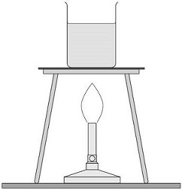
(a) Explain how the internal energy of the water changes as it is heated from 20 °C to 25 °C
___________________________________________________________________
___________________________________________________________________
___________________________________________________________________
___________________________________________________________________
(2)
(b) How is the particle model used to explain the difference in density between a liquid and a gas?
Tick (✓) one box.

Particles in a gas have less kinetic energy than particles in a liquid.
Particles in a gas have more potential energy than particles in a liquid.
Particles in a liquid are further apart than particles in a gas.
Particles in a liquid are larger than particles in a gas.
(1)
(c) A student measured the mass of boiling water that was turned into steam in five minutes.
Explain how the student could use this information to estimate the power output of the Bunsen burner in watts.
___________________________________________________________________
___________________________________________________________________
___________________________________________________________________
___________________________________________________________________
___________________________________________________________________
___________________________________________________________________
___________________________________________________________________
___________________________________________________________________
___________________________________________________________________
(4)
(Total 7 marks)

Mark schemes
Q1.
(a) 0.0 to 10.0 cm³
1
(b) the measured volume would be larger
1
(c) 0.4 (cm³)
1
(d) the results are repeatable
1
(e) subtract 0.02 from the measurement
1
(f)
or
1
(g)
1
m = 22 × 0.3
1
m = 6.6 (g)
1
[9]
Q2.
(a) (i) Z
1
(ii) X
1
(b) (i) moving randomly
1
(ii) stronger than
1
(c) (i) evaporation
1
(ii) any one from:
• becomes windy
• temperature increases
accept (becomes) sunny
“the sun” alone is insufficient
• less humid
1
[6]
Q3.
(a) Level 2: The method would lead to the production of a valid outcome. Key steps are identified and logically sequenced.
3−4
Level 1: The method would not necessarily lead to a valid outcome. Some relevant steps are identified, but links are not made clear.
1−2
No relevant content
0
Indicative content
• part fill a measuring cylinder with water
• measure initial volume
• place object in water
• measure final volume
• volume of object = final volume − initial volume
• fill a displacement / eureka can with water
• water level with spout
• place object in water
• collect displaced water
• measuring cylinder used to determine volume of displaced water
(b) 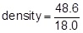
1
density = 2.70 (g/cm³)
1
an answer of 2.70 (g/cm³) scores 2 marks
(c) limestone
1
(d) eye position when using measuring cylinder
or
water level in can (at start) not at level of spout
or
not all water displaced by stone is collected in container
1
(e) volume would be lower / higher
1
[9]
Q4.
(a)
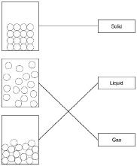
2 marks for all correct
1 mark for 1 or 2 correct
2
(b) B
1
(c) D
1
(d) the kinetic energy of the particles
1
(e) E = 0.250 × 334 000
1
E = 83 500 (J)
1
(f) sublimates
1
[8]
Q5.
(a) Level 2: The method would lead to the production of a valid outcome. The key steps are identified and logically sequenced.
3−4
Level 1: The method would not necessarily lead to a valid outcome. Some steps are identified, but the method is not fully logically sequenced.
1−2
No relevant content
0
Indicative content
• use a eureka/displacement can
• fill the eureka/displacement can with water
• fill the eureka/displacement can up to the spout
• place lime in eureka/displacement can
• collect water that overflows
• use a measuring cylinder to measure volume of water
OR
• use a measuring cylinder
• part fill the measuring cylinder with water
• measure the initial volume of water
• place lime in measuring cylinder
• record new volume of water
• volume of lime = new volume – initial volume
(b) mean =
1
mean = 2.2 (cm³)
1
(c) allows anomalous results to be identified and ignored
1
reduces the effect of random errors when using the equipment
1
(d) density =
1
density = 0.70 (g/cm³)
1
[10]
Q6.
(a) range of speeds
1
moving in different directions
accept random motion
1
(b) internal energy
1
(c) density = mass / volume
1
(d) 0.00254 / 0.0141
1
0.18
1
accept 0.18 with no working shown for the 2 calculation marks
kg / m³
1
[7]
Q7.
(a) (black) is a good absorber of (infrared) radiation
1
(b) (i) amount of energy required to change (the state of a substance) from solid to liquid (with no change in temperature)
melt is insufficient
1
unit mass / 1kg
1
(ii) 5.1 × 10⁶ (J)
accept 5 x 10⁶
allow 1 mark for correct substitution ie E = 15 × 3.4 × 10⁵
2
(c) (i) mass of ice
allow volume / weight / amount / quantity of ice
1
(ii) to distribute the salt throughout the ice
1
to keep all the ice at the same temperature
1
(iii) melting point decreases as the mass of salt is increased
allow concentration for mass
accept negative correlation
do not accept inversely proportional
1
(d) 60 000 (J)
accept 60 KJ
allow 2 marks for correct substitution ie E = 500 × 2.0 × 60
allow 2 marks for an answer of 1000 or 60
allow 1 mark for correct substitution ie
E = 500 × 2.0 or 0.50 × 2.0 × 60
allow 1 mark for an answer of 1
3
(e) Marks awarded for this answer will be determined by the Quality of Communication (QC) as well as the standard of the scientific response. Examiners should also apply a ‘best-fit’ approach to the marking.
0 marks
No relevant content
Level 1 (1–2 marks)
There is an attempt at a description of some advantages or disadvantages.
Level 2 (3–4 marks)
There is a basic description of some advantages and / or disadvantages for some of the methods
Level 3 (5–6 marks)
There is a clear description of the advantages and disadvantages of all the methods.
examples of the points made in the response
extra information
energy storage
advantages:
• no fuel costs
• no environmental effects
disadvantages:
• expensive to set up and maintain
• need to dig deep under road
• dependent on (summer) weather
• digging up earth and disrupting habitats
salt spreading
advantages:
• easily available
• cheap
disadvantages:
• can damage trees / plants / drinking water / cars
• needs to be cleaned away
undersoil heating
advantages:
• not dependent on weather
• can be switched on and off
disadvantages:
• costly
• bad for environment
6
[18]
Q8.
(a) solid
particles vibrate about fixed positions
1
closely packed
accept regular
1
gas
particles move randomly
accept particles move faster
accept freely for randomly
1
far apart
1
(b) amount of energy required to change the state of a substance from liquid to gas (vapour)
1
unit mass / 1 kg
dependent on first marking point
1
(c) 41000 or 4.1 × 10⁴ (J)
accept
41400 or 4.14 × 10⁴
correct substitution of
0.018 × 2.3 × 10⁶ gains 1 mark
2
(d) AB
changing state from solid to liquid / melting
1
at steady temperature
dependent on first AB mark
1
BC
temperature of liquid rises
1
until it reaches boiling point
dependent on first BC mark
1
[12]
Q9.
(a) random error
1
(b) thin string would affect the volume measurement less (than thick string)
allow thin string would displace less water (than thick string)
ignore absorption of water by string
1
(c) the measuring cylinder could not be used to measure to 2 dp
or
the resolution of the measuring cylinder is 0.2 cm³
allow the resolution is 0.1 cm³
ignore the resolution is too low
1
(d) subtract 0.02 g from the measured value
ignore zero the balance
1
(e) 0.44 cm³ = 4.4 × 10^{–7} m³
1
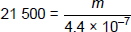
allow a correct substitution of an incorrectly / not converted value of V
1
m = 21 500 × 4.4 × 10^{–7}
allow a correct rearrangement of an incorrectly / not converted value of V
1
m = 0.00946 (kg)
or
m = 9.46 × 10⁻³ (kg)
allow an answer consistent with an incorrectly / not converted value of V
1
[8]
Q10.
(a) balance / scales
1
(b)
or
1
(c) 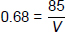
1
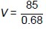
1
V = 125 (cm³)
1
(d) repeat readings (of volume) need taking (of each fruit) to show that the readings are close together
allow ‘the same’ for ‘close together’
1
[6]
Q11.
(a) the (mean) kinetic energy of the particles increases
allow the (mean) speed of the particles increases
‘kinetic energy increases’ is insufficient by itself
do not accept particles vibrating
1
which increases the (internal) energy of the water
ignore description of evaporation
1
(b) Particles in a gas have more potential energy than particles in a liquid.
1
(c) Energy given to water E = mL with quantities defined
1
allow with quantities defined
1
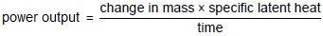
allow E = Pt equated with E = mL or stated in words
or
with quantities defined
1
time should be converted to seconds
or
use a time of 300 seconds
1
[7]

